Old, Archived Ricky Ding 1997 Dec 2023

Musical Tesla Coil Gun project

* Below is the audio envelope driving the Tesla Coil’s resonator system. The amplitude corresponds to the amount of energy injected into the system. The audio frequency (sine wave) is added on top of the falling ramp.

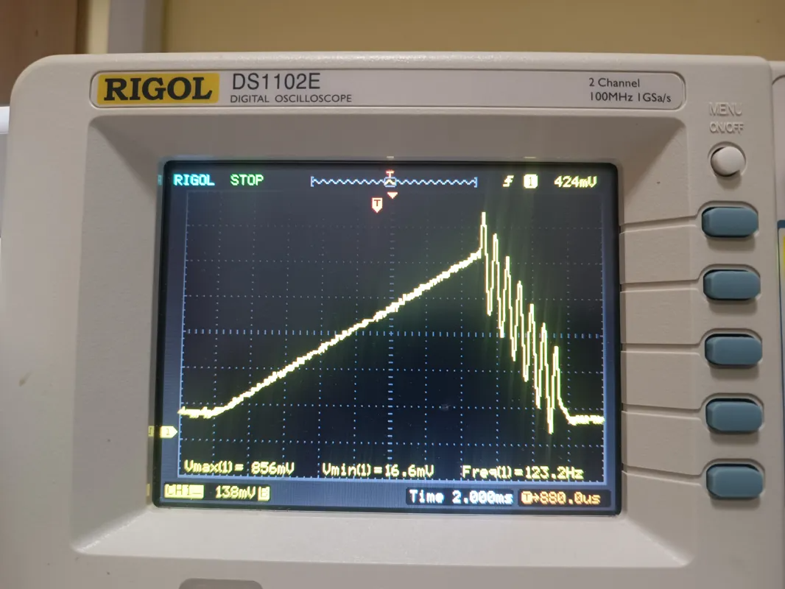

* Below is the PCB designed by myself, manufactured by JLCPCB, and soldered by hand at home. The components are purchased from Alibaba.

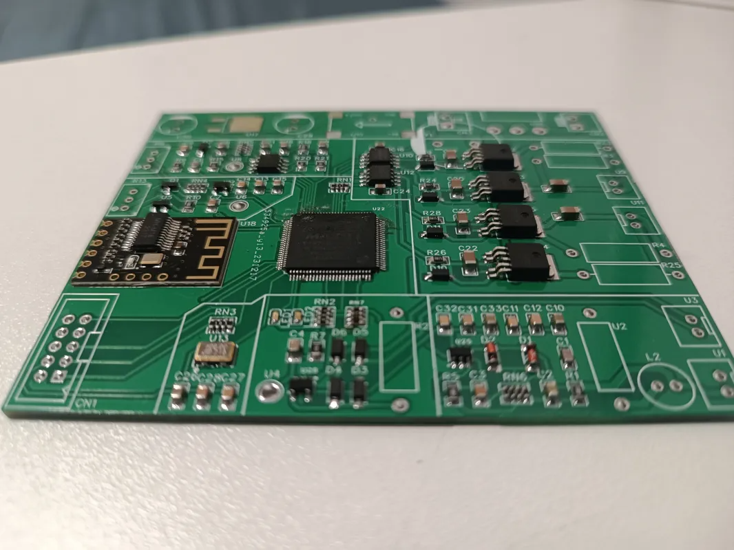

* Below is the core electronics part of the system, from left to right:
  + The “driver” board (16V)
    - Audio modulation module (generates the audio envelope)
    - M18 Bluetooth audio receiver
    - EPM240T100C5N low cost CPLD chip (runs Verilog code)
    - Resonant signal feedback module (Zero Current Switching)
    - Over Current Protection module (Pulse Density Modulation)
    - TC4424A + FDD8424H two stage Push-Pull Amplifier
  + The Phase-Shifted Full-Bridge Converter (300V)
    - Gate Driving Transformers
    - Current Feedback Transformers
    - FGH60N60SMD IGBT Phase-Shifted H-Bridge

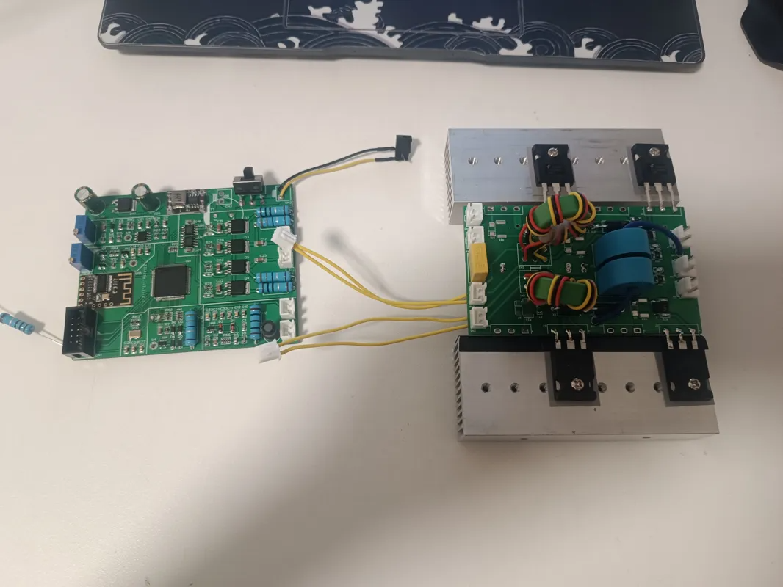

* Other modules:
  + 18650 batteries board, inverter board (16V to 300V)
  + Casing (designed and 3D-printed at home), Tesla Coil Resonator

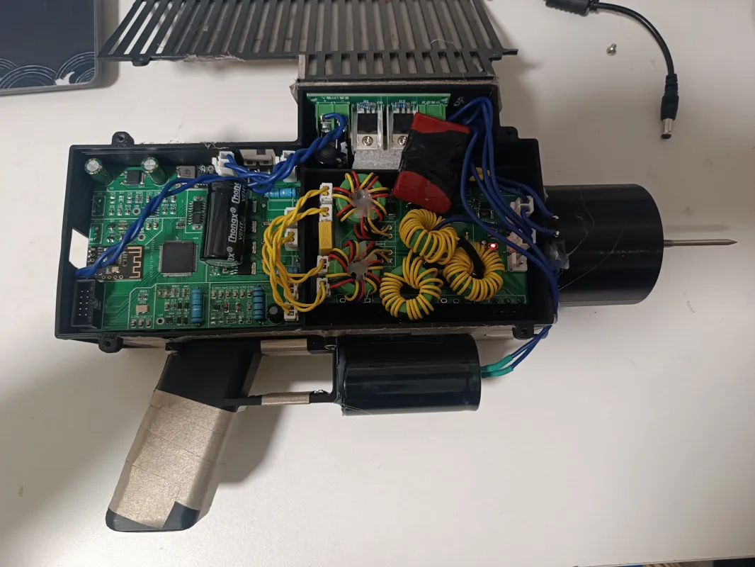

* Below is how it looks holding in hand and playing in action:

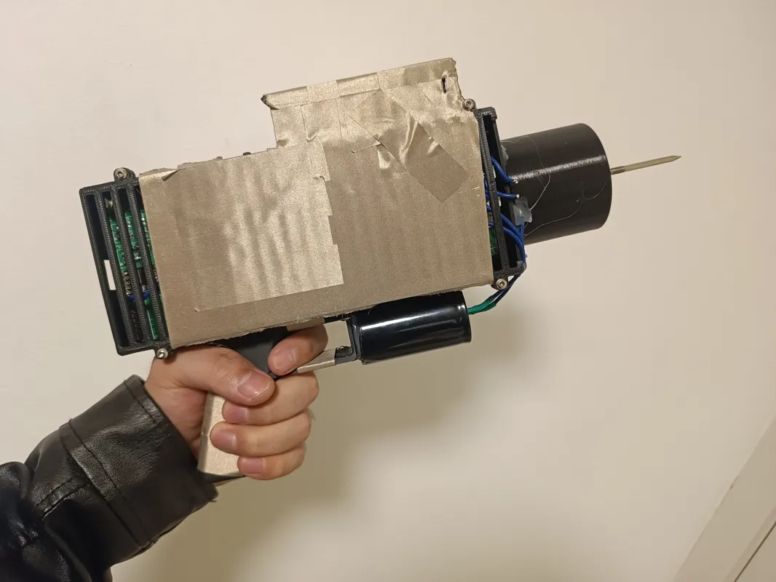

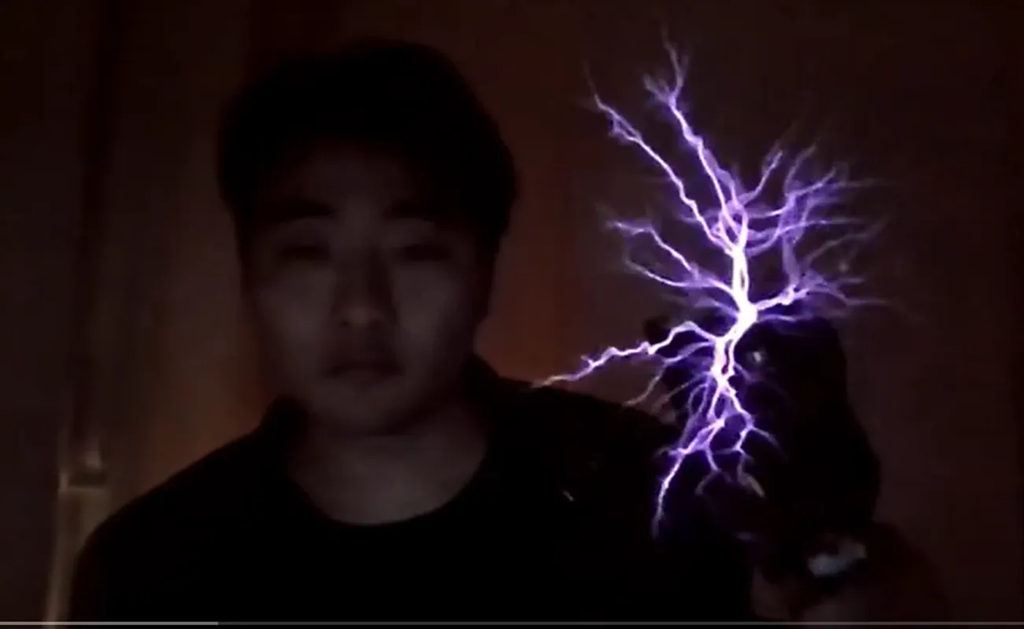

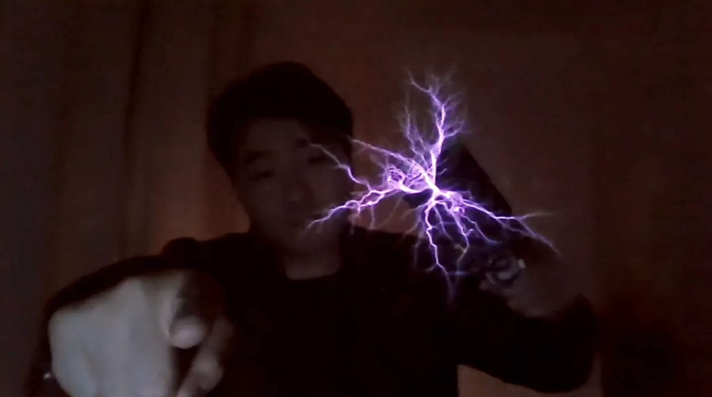

* Below are the schematics and PCB designs of the core driver board.

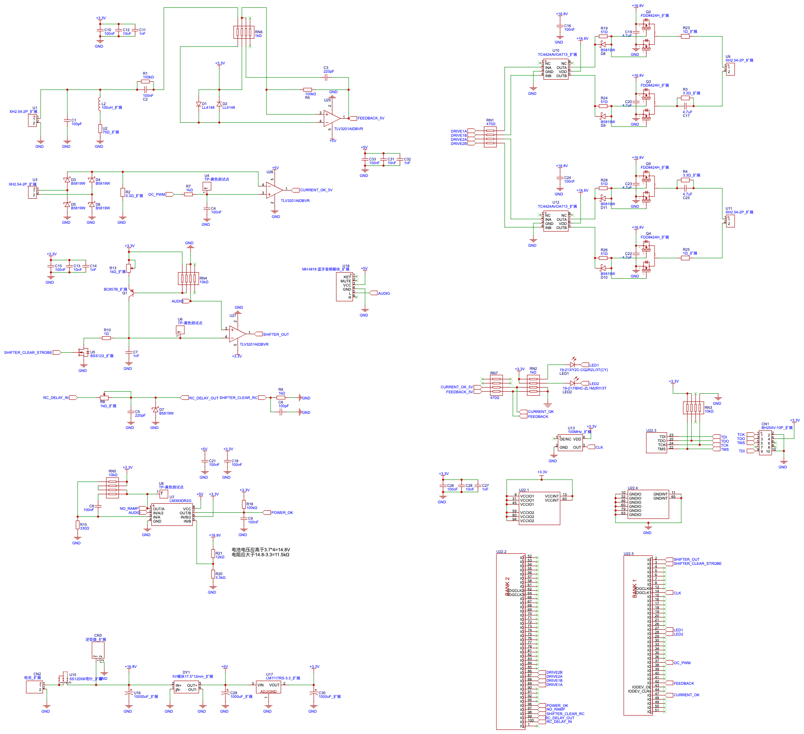

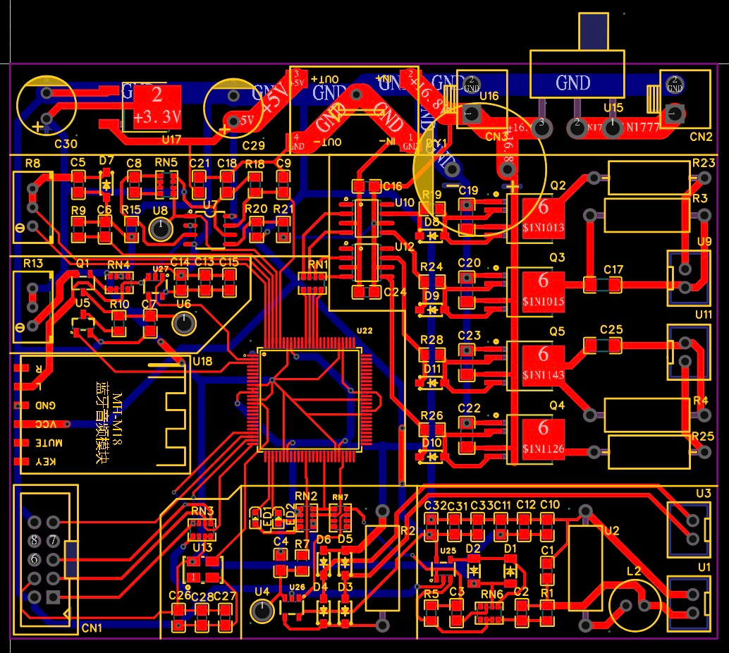

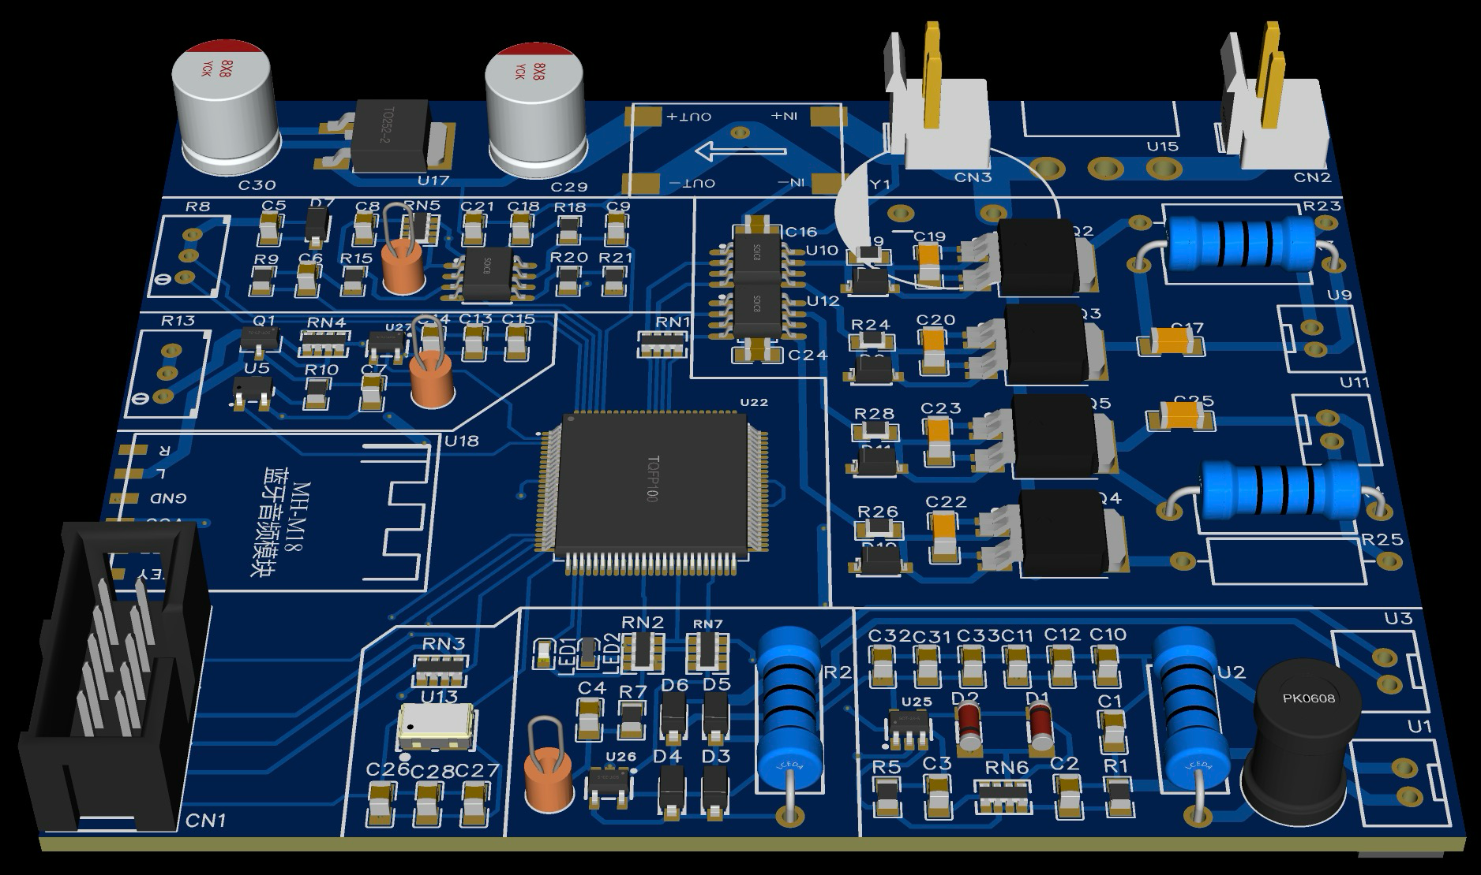

* Below is the Synthesizer App made using Vue3, one can upload MIDI music files, the app reads notes data (timing, frequency, duration), and generates various audio waveforms for the driver’s Bluetooth receiver based on a list of configurations, in order to control the energy envelope of the Tesla Coil system.

